Questions-1

BlockChain =

1. to get single window 0000 starting hash

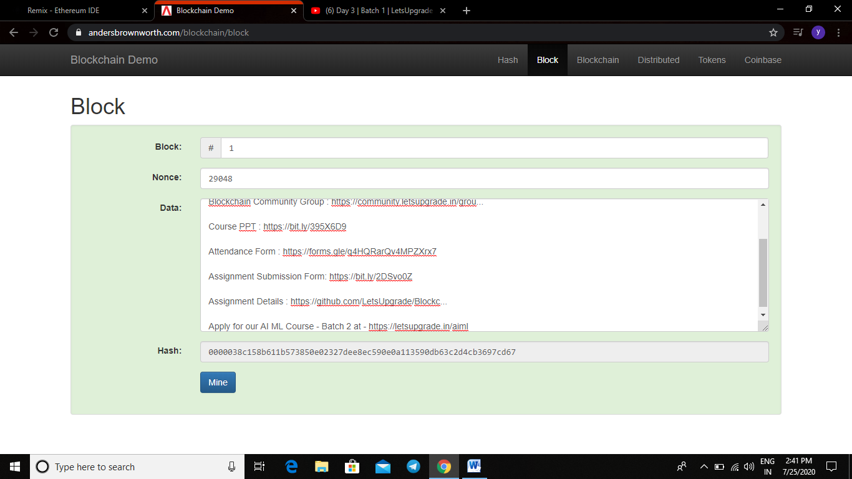

1. To multiple block finding proper **nonce to get 1st four 0000**

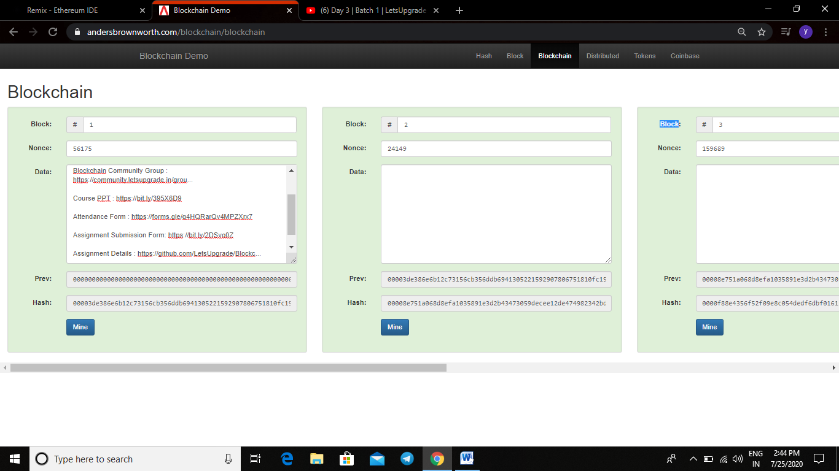

Assignment 2= making simple contract to run solidity code on this remix software

(Don’t know how to use and how to code at this stage so this is just a basic )

